Pictures for the EMO press release:

Metalworking inspired by the stars
EMO Hannover 2019: Astrophysicists looking to optimise milling

((06-01-Erium-KI-Einsatz.jpg))

Astrophysicists Theo Steininger and Maksim Greiner are looking for new applications for artificial intelligence software that has already proven itself in the automotive industry.

Photo: Erium

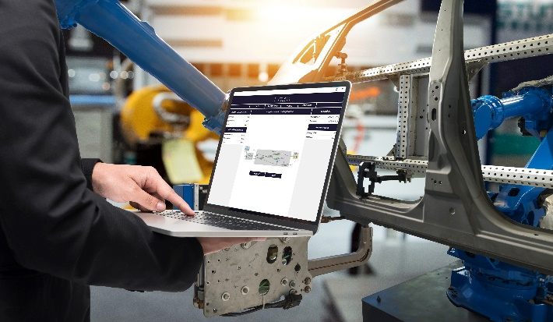

((06-02-Steininger und Greiner.jpg))

Theo Steininger (left) and Maksim Greiner, founders of Erium GmbH, Garching: Is the greater spindle wear resulting from working close to edges worthwhile? "The AI program would also take soft factors such as customer relationships into account."

Photo: Erium

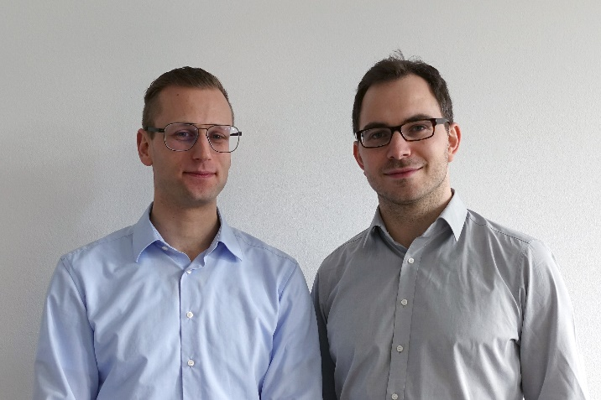

You will find texts and images relating to the EMO Hannover 2019 on the internet at
https://www.emo-hannover.de/en/press/press-releases/press-releases/press-releases.xhtml

You can also follow the EMO Hannover using our social media channels

http://twitter.com/EMO_HANNOVER

https://de.industryarena.com/emo-hannover

www.linkedin.com/company/emo-hannover

http://www.youtube.com/metaltradefair

http://facebook.com/EMOHannover

