Pictures for the EMO press release:

High-quality sensor data is a crucial requirement for Industry 4.0

On show at EMO Hannover 2019 – Sensor technology is a key mechanical engineering component

((08-01-Jürgen Fleischer.jpg))

Jürgen Fleischer, wbk, Karlsruhe: Simulations of components, assemblies and machines give us a better understanding of the mechanical effects encountered in production plants. We use this knowledge to make targeted use of sensors and to interpret the captured data more efficiently."

Photo: wbk

((08-02-Thomas Päßler.jpg))

Thomas Päßler, IWU, Chemnitz: "Real-time data acquisition becomes indispensable when it's the only way to prevent damage to hardware or workpieces. This applies in the case of tool breakage or excessive stress on assemblies such as bearings or frame components, for ex- ample."

Photo: IWU

((08-03-Jörg Stahlhmann.jpg))

Jörg Stahlmann, Consenses, Roßdorf: "You have to identify the point up to which real-time makes sense. There is also the question of how the data is synchronised. The sampling rates required for describing the process adequately are also im- portant."

Photo: Consenses

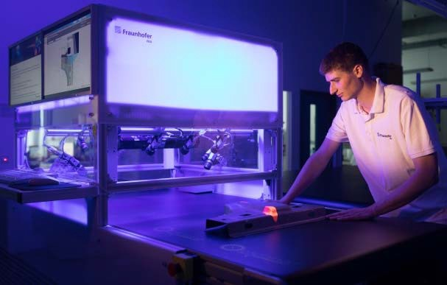((08-04-Xeidana.jpg))

Xeidana is a software system for quality control.

Photo: IWU

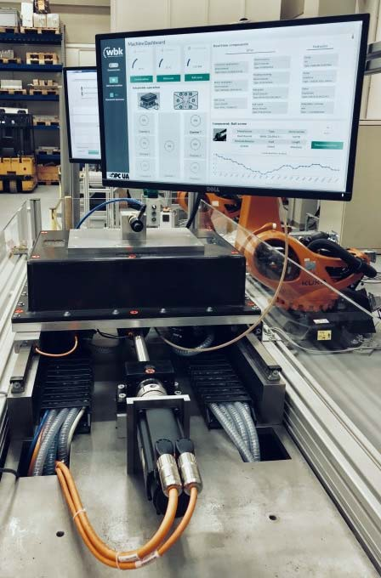((08-05-Messdemonstrator.jpg))

A measurement demonstrator illustrates the adaptive lubrication and condition monitoring of ball screw drives.

Photo: wbk

You will find texts and images relating to the EMO Hannover 2019 on the internet at https://www.emo-hannover.de/en/press/press-releases/press-releases/press-releases.xhtml

You can also follow the EMO Hannover using our social media channels

http://twitter.com/EMO_HANNOVER

https://de.industryarena.com/emo-hannover www.linkedin.com/company/emo-hannover http://www.youtube.com/metaltradefair
http://facebook.com/EMOHannover

