Pictures for the EMO press release:

Doomed to fail without AI?

EMO Hannover 2019: Applying an "engineering approach" to the systematic use of artificial intelligence

((09-01-Jörg Krüger.jpg))
Prof. Jörg Krüger, Institut für Werkzeugmaschinen und Fabrikbetrieb IWF, Berlin: "We need a more systematic approach if we wish to use AI to tap new value creation potential in production."

Photo: IFW Berlin

((09-02-Trumpf-KI Maschine.jpg))

Artificial Intelligence uses a fully automatic laser system to analyse the removal of cut sheet metal parts – initially unsuccessfully, but ultimately successfully – and automates the procedure using the resulting data.

Photo: Trumpf

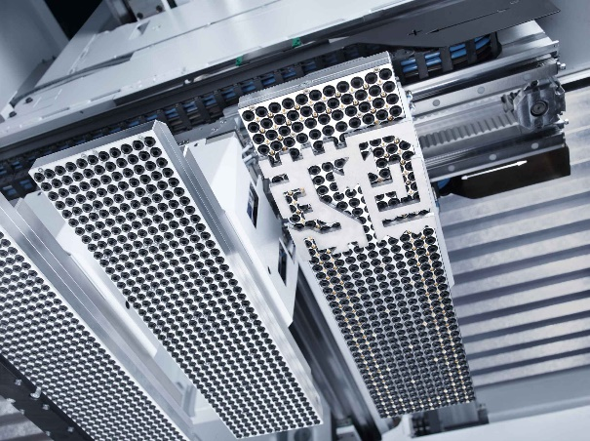

((09-03-Thomas Schneider.jpg))

Dr. Thomas Schneider, Trumpf: "Artificial intelligence does not kill jobs. It's a further logical step towards securing Germany's competitiveness and prosperity."

Photo: Trumpf

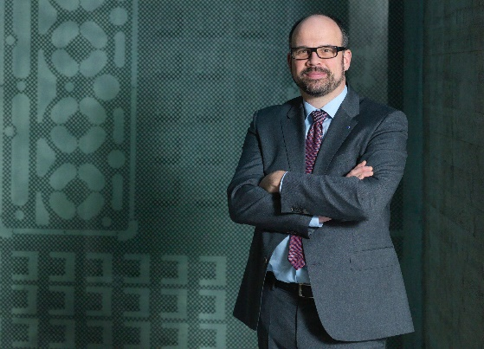

You will find texts and images relating to the EMO Hannover 2019 on the internet at
https://www.emo-hannover.de/en/press/press-releases/press-releases/press-releases.xhtml

You can also follow the EMO Hannover using our social media channels

http://twitter.com/EMO_HANNOVER

https://de.industryarena.com/emo-hannover

www.linkedin.com/company/emo-hannover

http://www.youtube.com/metaltradefair

http://facebook.com/EMOHannover

