Pictures for the EMO press release:

Protecting machine tools from cyber attacks

EMO Hannover 2019 showcasing solutions for complex networked systems

((16-01_Bild1_Berg-Achim-Bitkom.jpg))
"German industry is under constant digital fire – from petty digital criminals, organised crime and even state-backed hackers," says Bitkom President Achim Berg.

Photo: Bitkom

((16-02_Philipp Echteler.jpg))

"Promptly installing updates and security patches considerably reduces the risk of cyber attacks," says Philipp Echteler from Balluff.

Photo: Balluff

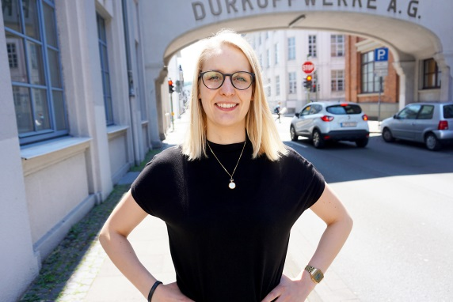
((16-03_Juliane Schneider.jpg))

Juliane Schneider, Junior Product Manager at symmedia, emphasises: "When it comes to handling sensitive data, any human negligence poses a security risk."

Photo: symmedia

((16-04_Overview.jpg))

In times of Industry 4.0, there are increasing data security demands on complex, networked systems.

Photo: Balluff
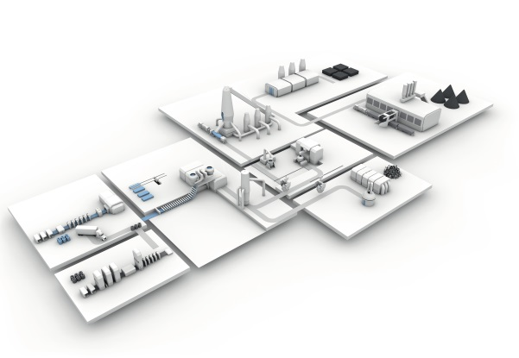

You will find texts and images relating to the EMO Hannover 2019 on the internet at
https://www.emo-hannover.de/en/press/press-releases/press-releases/press-releases.xhtml

You can also follow the EMO Hannover using our social media channels

http://twitter.com/EMO_HANNOVER

https://de.industryarena.com/emo-hannover

www.linkedin.com/company/emo-hannover

http://www.youtube.com/metaltradefair

http://facebook.com/EMOHannover

