Pictures for the METAV Press Release:

Awareness protects against hackers

((03-01 Steffen Zimmermann.jpg))

Steffen Zimmermann, Head of Competence Center Industrial Security at VDMA: "IT not only makes machines smart and interactive, but also more susceptible to cyber attacks".
Photo: VDMA

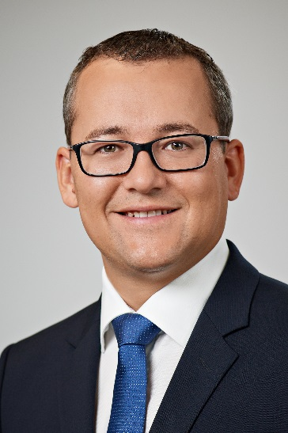

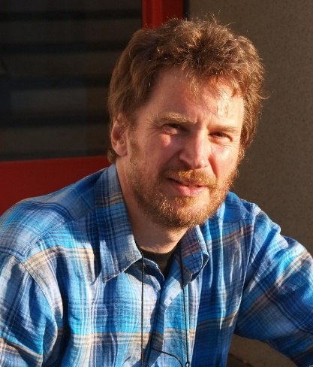
((03-02-Heinz-Uwe Gernhard.jpg))
Heinz-Uwe Gernhard, IT Security and Application (C/TED1) at Robert Bosch GmbH: "In today's networked world, nobody is safe from a cyber attack. A change of heart must take place here."
Photo: Bosch

((03-03 Schulung.jpg))

Look out! Cyberattacks can be prevented by training employees in the company or online - or at least by reducing the impact.
Photo: Siemens

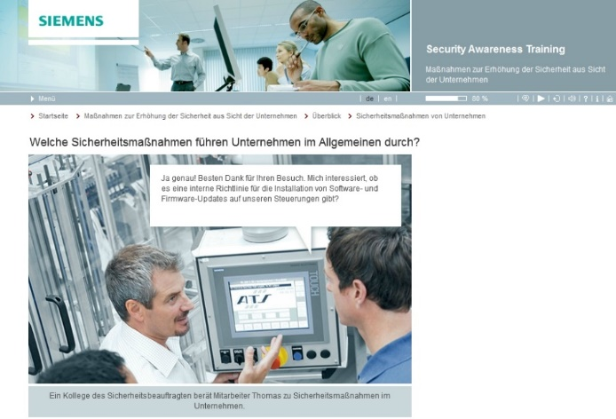

Printable versions of the images are available from:
http://medianet.messe-duesseldorf.de/press/metav/assets.html
https://www.metav.com/en/Press/Press_material/VDW_Press_Releases

