**Pictures for the METAV Press Release:**

**METAV 2020 – Combining modern metalworking theory and practice**

((06-01 Maschinenfabrik Reinhausen augmentedOperator.jpg))

Various MES/MOM (Manufacturing Execution System/Manufacturing Operations Management) working groups are currently laying the foundations for digitalising industrial shop floors.

Photo: Maschinenfabrik Reinhausen

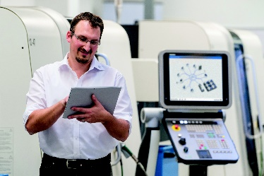

((06-02 Maschinenfabrik Reinhausen 3D_Spinne.jpg))

Maschinenfabrik Reinhausen's MOM system allows production staff to harmonise entire machine groups.

Photo: Maschinenfabrik Reinhausen

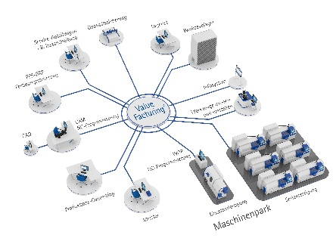

((06-03 JAT-Antriebstechnik-Präzision-und-Leidenschaft-erleben.jpg))

The Jena-based experts develop and produce tailor-made drive systems for machine builders. The 2020 Düsseldorf Innovation Forum will feature extensive information on customer-specific servo drive technology and mechatronic systems.

Photo: JAT – Jenaer Antriebstechnik

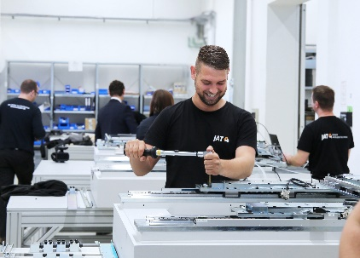

((06-04 JAT-Antriebstechnik-Rundtische-präzise-positionieren.jpg))

A new series of rotary tables from the drive technology specialists ensures even greater precision and dynamics in production machines.

Photo: JAT – Jenaer Antriebstechnik

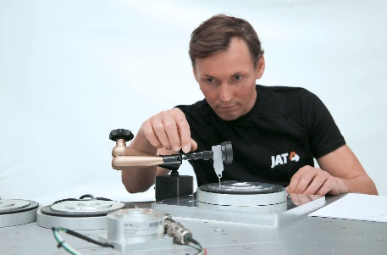

((06-05 Stäubli Robotics Peter Pühringer.jpg))

Peter Pühringer, Division Manager at Stäubli Robotics Bayreuth: "We now offer special protected versions of all robot kinematic systems."

Photo: Stäubli Robotics

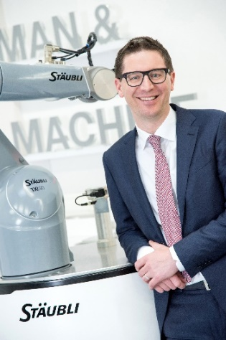

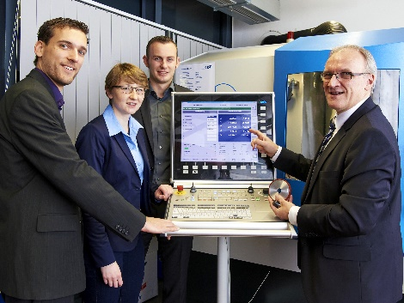

((06-06 Professor Dirk Biermann 2019.jpg))

Prof. Dirk Biermann (right), Head of the Institute of Machining Technology (ISF) at the Technical University of Dortmund and member of the German Academic Association for Production Technology (WGP), gives an insight into current developments in metalworking as keynote speaker at the Düsseldorf 2020 Innovation Forum.

Photo: TU Dortmund – ISF

Printable versions of the images are available from:

<http://medianet.messe-duesseldorf.de/press/metav/assets.html>