Pictures for the Press Release:

Are grinding machine safety devices overdesigned?

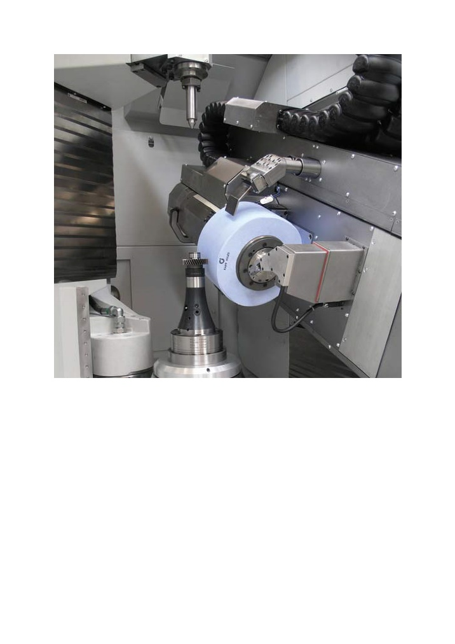
((t02-01_Arbeitsraum.jpg))
Workspace of a gear grinding machine. Very high rotational energy levels can arise in large grinding tools, such as those used for generation grinding. If a grinding wheel does burst, it can cause serious injury to the machine operator.

Photo: Kapp

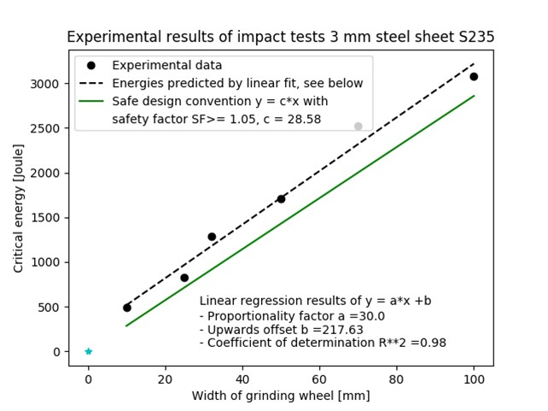
((t02-02_Auslegungskonvention.jpg))

Safe design convention for 3 mm sheet steel

Photo: BGHM / VDW

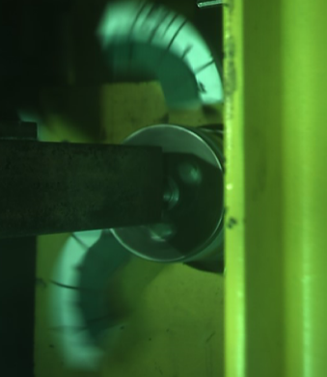
((t02-03_berstszenario.jpg))
A bursting grinding wheel in the workspace of a machine tool.

Photo: IWF TU Berlin

Printable versions of the images are available from: https://www.metav.com/en/Press/Overview_Press
http://medianet.messe-duesseldorf.de/press/metav/assets.html

