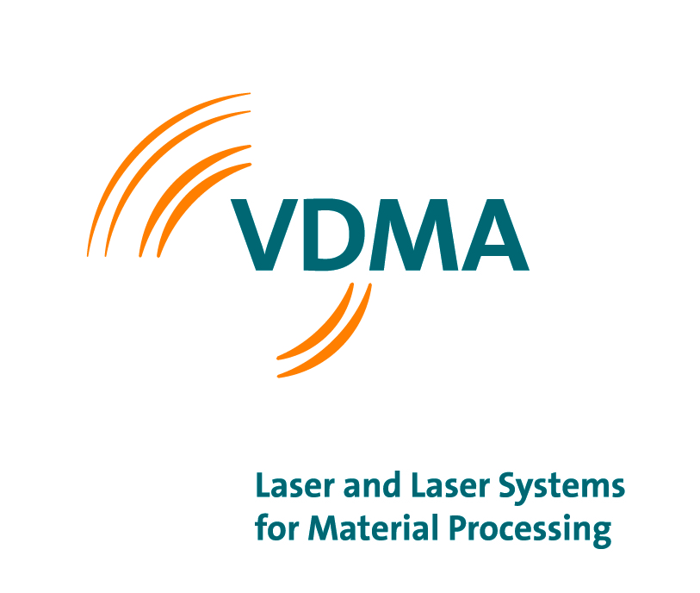Contact
Dr. Moritz Förster
E-Mail: m.foerster@vdw.de
Phone: +49 69 756081-22
Web: laser.vdma.org
Key figures of the German laser industry

Development of the branch 2019 for Laser Systems with CO₂-, Solid-State
and Diode Lasers

Production, order intake and exports, Germany in Mio. Euro

 | 2018 | 2019 | VR 19/18
Orders
Domestic | 229 | 153 | -33%
Foreign | 1.077 | 901 | -16%
Total | 1.306 | 1.054 | -19%
Production | 1.055 | 869 | -17%
Exports | 950 | 782 | -18%

Share of total exports, Germany
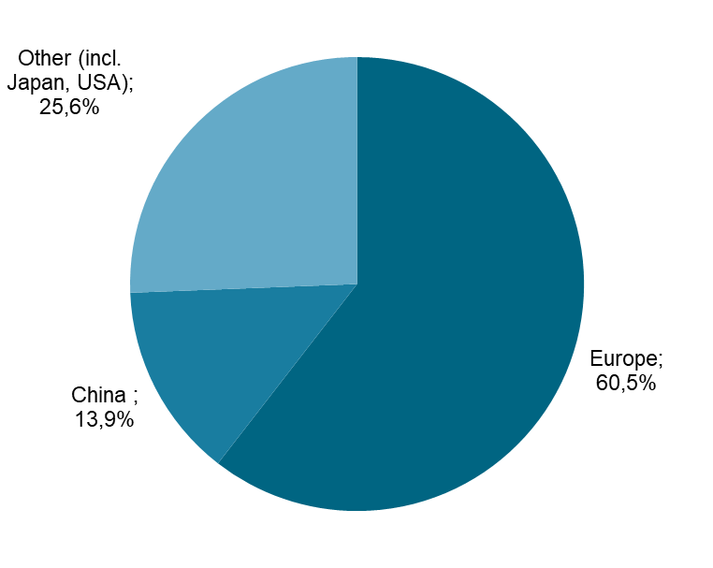

Source: VDMA e. V., Working Committee Laser and Laser Systems for Material Processing

