**Pictures for the METAV Press Release:**

**Automation – the digital order of the day**

((01-01_ Dr. Bernard Cubizolles.jpg))

Dr. Bernard Cubizolles, Senior Global Marketing Manager at GE Digital in San Ramon (USA), recommends that machine manufacturers and their customers use digital tools which will allow them "to use data that was previously either not available or not used".

Photo: GE Digital

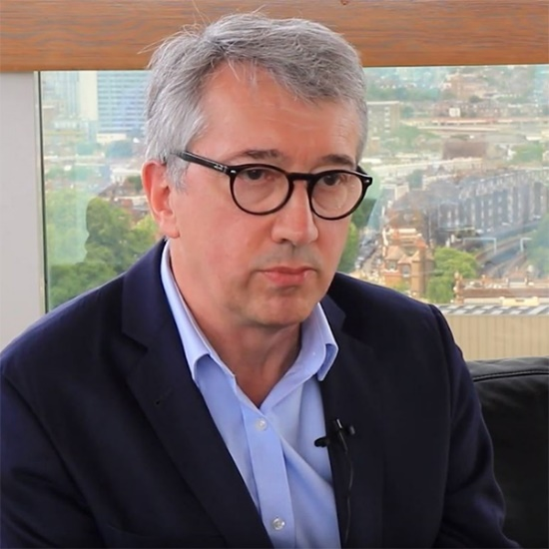

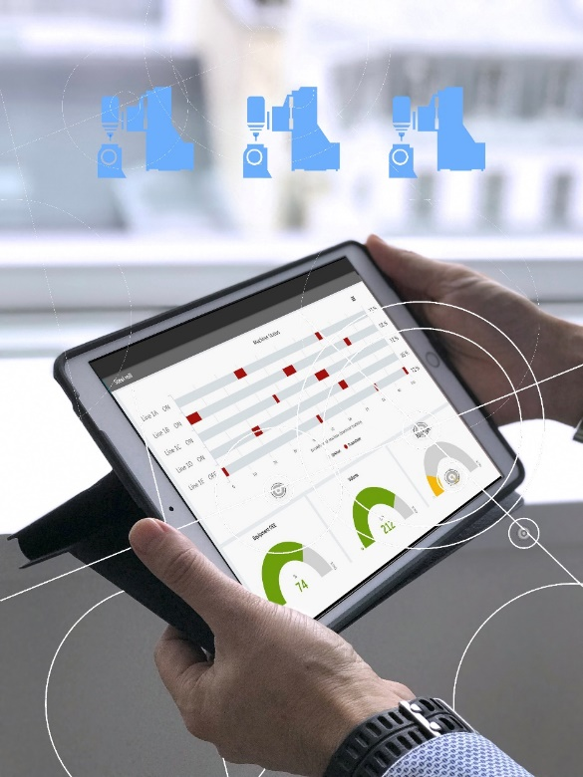

((01-02_ Produktionsprozesse.jpg))

GE is presenting digital tools at METAV reloaded 2020 that enable users to continuously improve and streamline their production processes.

Photo: GE Digital

.

((01-03_Nachbearbeitungszelle_Future AM.jpg))

Siemens has developed a family of digital twins which permits virtual mapping of the entire machine tool, from its mechanics and response through to its control.

Photo: Siemens

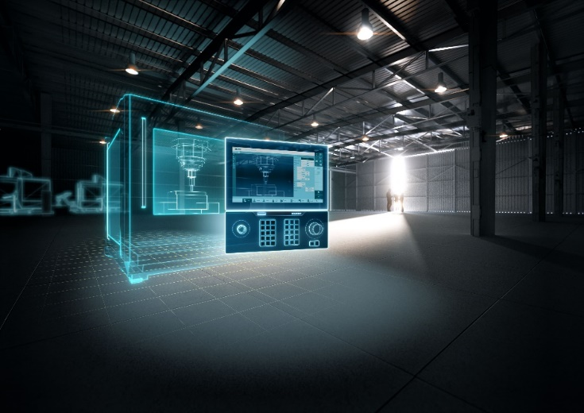



((01-04_ Josef Hammer.jpg))

Josef HammerPromotion Manager at Machine Tool Systems of Siemens AG, Nuremberg: "Intelligent motion control functions increase surface quality while reducing machining time. This yields significant increases in productivity."

Photo: Siemens

((01-05_ Rico Müller.jpg))

Rico Müller, Project Manager for CAD/CAM automation at Open Mind Technologies AG, Weßling: "Many of our users are already automating their CAD/CAM programming, which gives them a significant competitive advantage."

Photo: Open Mind Technologies

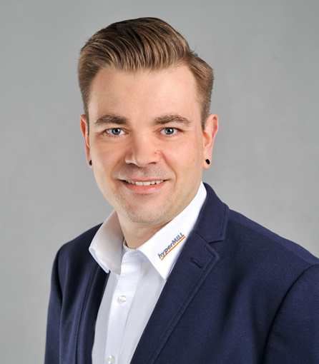

((01-06_ hyperMILL-Automation Center.jpg))

The hyperMILL Automation Center allows users to automate the programming for simple components themselves.

Photo: Open Mind Technologies

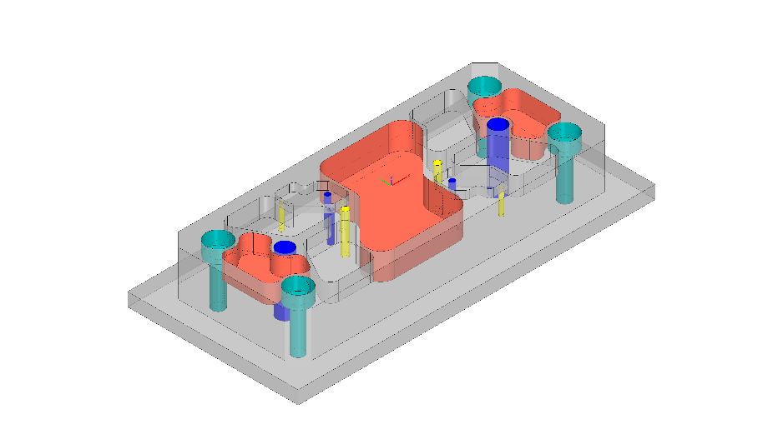

Printable versions of the images are available from:

<http://medianet.messe-duesseldorf.de/press/metav/assets.html>