Pictures for the METAV Press Release
Supply chains – From endurance test to new alliances
METAV digital to showcase solutions for more flexible value chains

((03-01_ Andreas Gützlaff.jpg))
Andreas Gützlaff, Head of the WZL Production Management Department at RWTH Aachen University says: "Managed complexity can yield savings of up to 15 per cent in the operating result."
Photo: WZL, RWTH Aachen

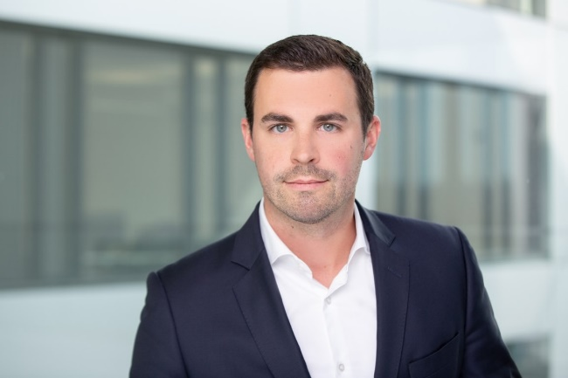

((03-02_ Benjamin Eichinger – Scoutbee.jpg))
"Yes, there are shocks that hit companies, but there are also tools that can help," says Benjamin Eichinger, Director Sales Germany at Scoutbee.
Photo: Scoutbee GmbH

.
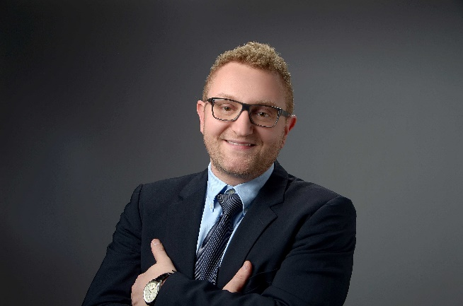
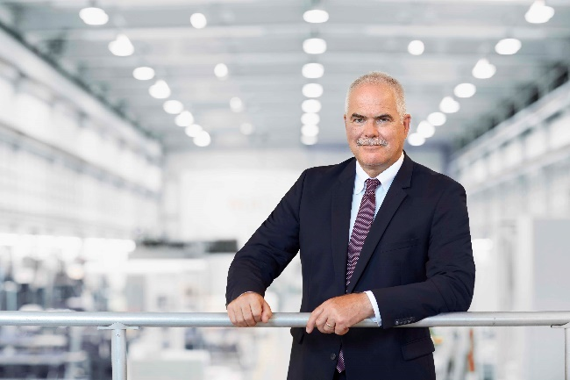
((03-03_ Manfred Maier – Heller jpg))
Manfred Maier, Chief Operating Officer at Heller: "In general, the goal is to have a dual or even, in some product groups, a multiple sourcing strategy."
Photo: Gebr. Heller Maschinenfabrik

((03-04_ Heller Fertigung.jpg))
Individual customer requirements, increasing automation and digitalisation, services which accompany machine tools over their entire life cycle: simple supply chains are becoming complex value creation networks.
Photo: Gebr. Heller Maschinenfabrik

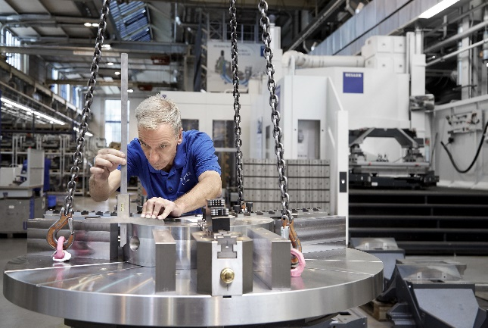

Printable versions of the images are available from
https://metav-digital.de/en/media/supply-chains-from-endurance-test-to-new-alliances-metav-digital-to-showcase-solutions-for-more-flexible-value-chains
and
https://metav-digital.de/en/media/

