**Pictures for the METAV digital Press Release:**

**Focus on Automation**

**METAV digital showcasing automation solutions for efficient processes in modern metalworking**

((01 Paul Horn GmbH PTS-Detail.jpg))

PTS system from Horn and Kistler: The smart tool holder for Index multi-spindle machines keeps users informed about the condition of the tool during the machining process.

Photo: Paul Horn GmbH

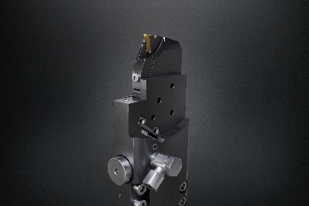

((02 Paul Horn GmbH PTS Personenhand.jpg))

When used with sliding head lathes, the sensor can measure cutting forces from just a few Newtons.

Photo: Paul Horn GmbH

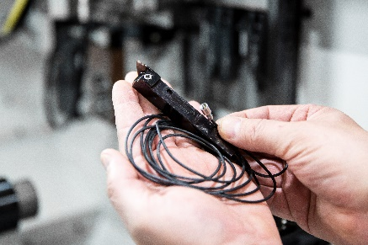

((03 EMCO Automationslösungen.jpg))

A wide product range, including numerous options for customising and automating the machines, is already being offered by EMCO.

Photo: EMCO GmbH

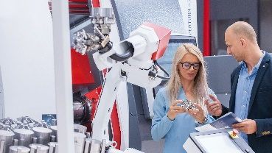

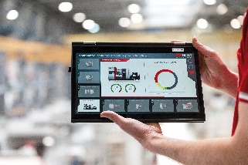

((04 EMCO EMCONNECT.jpg))

The EMCONNECT digital process assistant provides connectivity for optimal workflows and increased productivity.

Photo: EMCO GmbH

((05 EMCO Dr Ing Stefan Hansch CEO.jpg))

Dr.-Ing. Stefan Hansch, CEO EMCO GmbH: "If I were asked to give a general recommendation, I'd say that everybody currently needs two 'maps' – short-term, flexibly adaptable programmes that can be quickly adapted as required. But, at the same time, it's important not to lose sight of or undermine your company's vision and long-term strategic goals."

Photo: EMCO GmbH

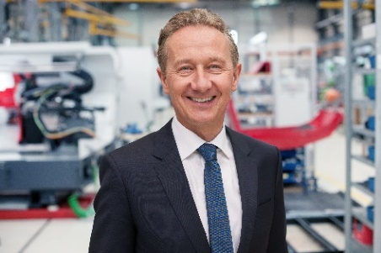

((06 ISCAR NEU TGTBQ D80 - TANGFGRIP app.jpg))

In addition to numerous high-performance products and digital tools, Iscar will be presenting various world firsts from its new NEOLOGIQ campaign at METAV digital.

Photo: ISCAR Germany GmbH

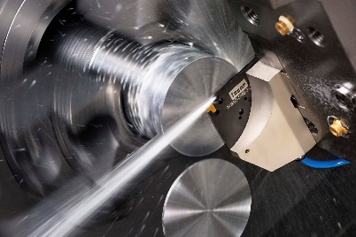



((07 ISCAR Erich Timons.JPG))

Erich Timons, CTO / Technical Director and Member of the Executive Board at Iscar Germany GmbH

Photo: ISCAR Germany GmbH

((08 ISCAR NEU NEOLOGIQ LOGO.jpg))

Photo: ISCAR Germany GmbH



((09 TU_Dortmund_GRK2193.png))

Research group 2193 is exploring the "Adaptation intelligence of factories in dynamic and complex environments".

Photo: TU Dortmund University

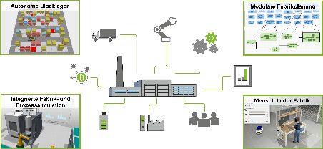

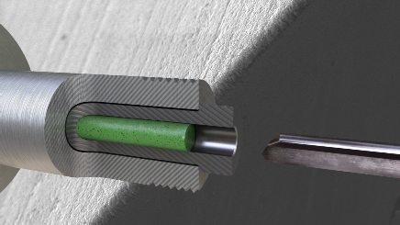

((10 TU_Dortmund_ToolPrep.png))

Cutting edge preparation is crucial in determining the performance of cutting tools: The [Tool]Prep process developed by the Institute of Machining Technology (ISF) at TU Dortmund University is universally applicable and easy to implement. It facilitates cutting edge preparation on shank tools.

Photo: TU Dortmund University – ISF