Pictures for the METAV Press Release
New corporate culture in smart factories
METAV digital to showcase work process solutions which favour "context over control"

((03-01_ Smart Watch.jpg))
All information shown in real time on a smart watch.

Photo: ifp Software GmbH

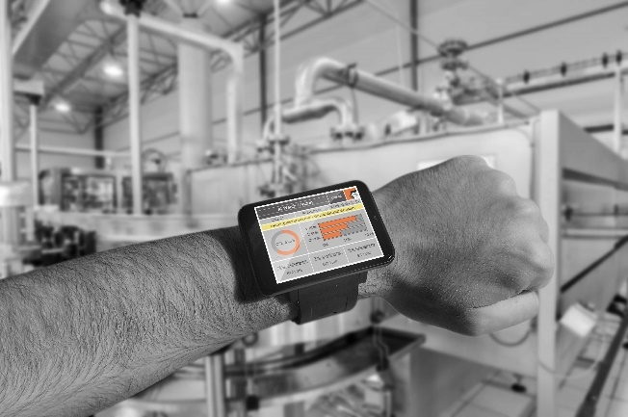

((03-02_ Cobots.jpg))
Cobots don't replace employees, they cooperate with them.

Photo: Müller Maschinentechnik

.
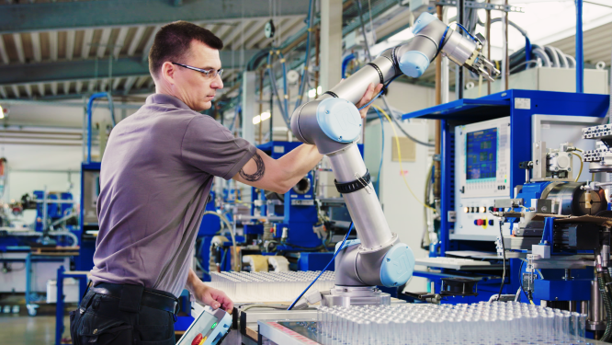

((03-03_ Einheiten verbunden. jpg))
All units are interconnected and centrally controlled.

Photo: Bosch Group

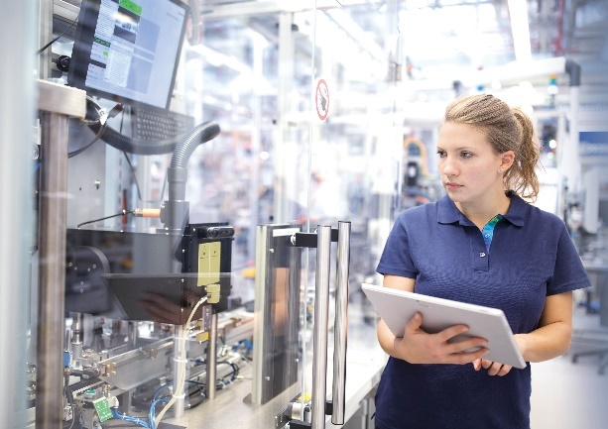

Printable versions of the images are available from

and
https://metav-digital.de/en/media/

