Pictures for the METAV digital Press Release:
Open community driving machine tool industry forwards

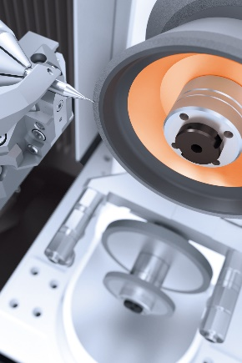
((01 VOLLMER Bearbeitung von Hartmetall-Fräsern.jpg))

Machining of carbide cutters.

Photo: Vollmer Werke Maschinenfabrik GmbH

((02 VOLLMER Dr Stefan Brand.jpg))

Dr Stefan Brand, CEO of the Vollmer Group: "METAV digital 2021 will allow Vollmer to present its latest innovations to an international trade fair audience – despite corona.“

Photo: Vollmer Werke Maschinenfabrik GmbH
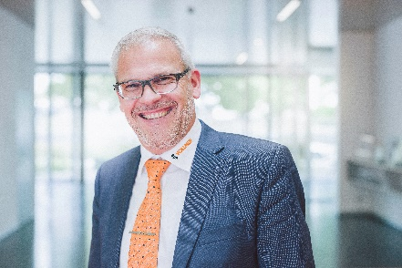

((03 EMCO Fraesspindel Taschenfraesen.jpg))
Elaborate pocket milling on an Emco machining centre. At METAV digital, interested visitors will be able to pick up extensive expert knowledge on machining processes and machine tools.

Photo: EMCO GmbH
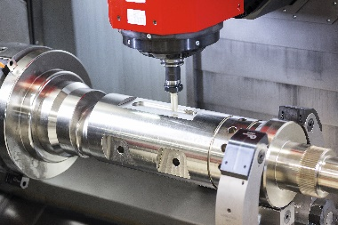

((04 EMCO Guenter Pumberger.jpg))
Günter Pumberger, Product Manager Digitalisation, Emco GmbH: "umati facilitates plug-and-work machining, which makes it much easier to integrate the machines into the production environment. This basically does away with the need for coordination between the different partners and for specific adjustments to the interfaces."

Photo: EMCO GmbH
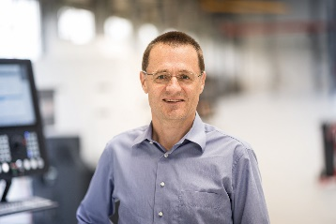

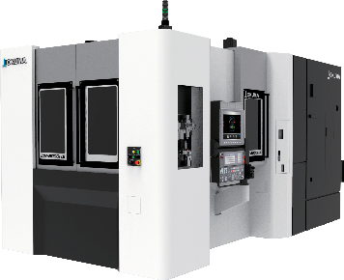
((05 OKUMA MB-5000HII.png))
Horizontal machining centre from Okuma.

Photo: Okuma Europe GmbH

((06 OKUMA Juergen Klaeser.jpg))

Jürgen Kläser, Senior Manager FA / IT at Okuma Europe GmbH.

Photo: Okuma Europe GmbH
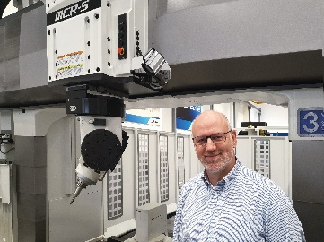

((07 Logo umati.jpg))

Photo: German Machine Tool Builders’ Association

Printable versions of the images are available from
https://metav-digital.de/en/media/supply-chains-from-endurance-test-to-new-alliances-metav-digital-to-showcase-solutions-for-more-flexible-value-chains
and
https://metav-digital.de/en/media/

