From Sylke Becker
Phone +49 69 756081-33
Telefax +49 69 756081-11
Email s.becker@vdw.de

Images for the METAV Press Release
Shortening payback time on investments
((01_Sven_Kreusel_DATRON.jpg))

Sven Kreusel, Head of Global Sales at Datron AG, is convinced that energy efficiency will be one of the key selling points for products in the machine tool sector in the future.

Photo: Datron AG
((02_DATRON_Video.png))

Comparing power consumption: Marc Reis, Department Head at Datron Tech Academy, demonstrated in a YouTube video how a Datron neo series milling machine consumes less power than a standard hair dryer.

Photo: Datron AG
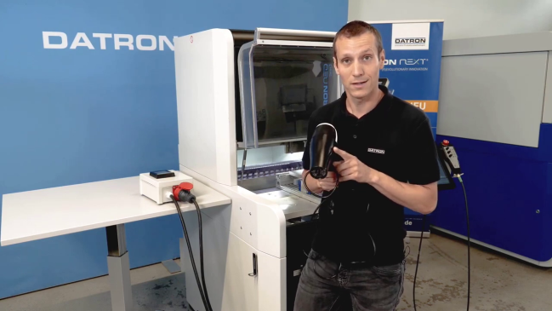
((03_Philipp_Schraml_ETA_Solutions.jpg))
The best way to maximize the effect of energy efficiency measures in new procurements, retrofits or similar projects is to plan them in from the outset, says Dr. Philipp Schraml, Managing Director of ETA-Solutions.

Photo: ETA-Solutions GmbH / Emily Broschk

((04_ETA_Solutions_Abwaerme.jpg))
"Bottom up” implementation of energy efficiency measures is the most effective approach, according to ETA-Solutions. This is because it does away with the need for energy-intensive dissipation of waste heat at the plant level.

Photo: PTW TU Darmstadt / Jan Hosan

Photo: EMCO GmbH
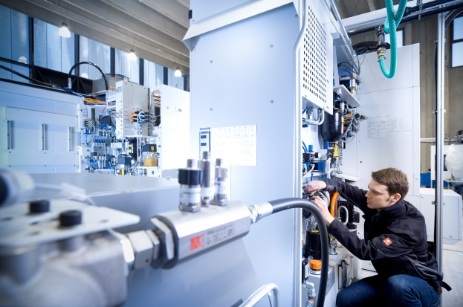

((05_ETA_Solutions_Thermografie.jpg))
Thermography can help identify inefficient units, such as unregulated hydraulic systems.

Photo: ETA Solutions GmbH / Jan Hosan

Printable versions of the images are available from:
https://www.metav.com/en/Press/Latest_Information/VDW_Press_Releases/Shortening_payback_time_on_investments?_ga=2.259078410.1231436016.1650377615-1462190235.1637052551

You can also find this press release at

https://www.metav.com/en/Press/Latest_Information/VDW_Press_Releases/Shortening_payback_time_on_investments?_ga=2.259078410.1231436016.1650377615-1462190235.1637052551

