Images for the METAV Press Release

Mastery of complex manufacturing processes for electric vehicles

(01Albrecht Präzision APC Slim5-Spannfutter Metav 2022 E_Mobilität.jpg)

Chucks from Albrecht Präzision with a clamping range of 2 to 20 mm diameter: for the reliable machining of e-mobility components.

Photo: Albrecht Präzision GmbH & Co.KG

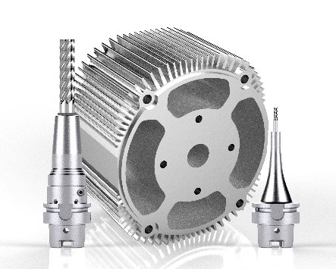

(02 Albrecht Präzision Micro-Spannfutter Metav 2022 E_Mobilität.jpg)

With a clamping range of 1 to 6 mm, a further chuck series from the southern Germany company is suitable for machining small components with deep recesses, such as control housings or sensor holders.

Photo: Albrecht Präzision GmbH & Co.KG (03 WZL Aachen Verzahnung METAV 2022 E-Mobilität.jpg)

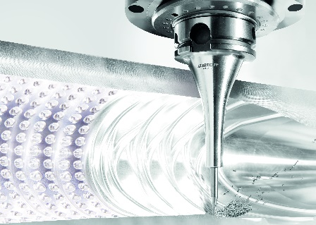

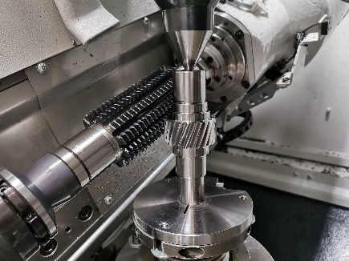

Electric vehicles tend to require fewer gears. However, even greater precision is usually required in their manufacture than for parts used in internal combustion engines.

Photo: WZL, RWTH Aachen

(04 WZL Aachen_Umformen_Brennstoffzelle METAV 2022 E-Mobilität.jpg)

Electromobility is creating a need for new drive concepts, in which fuel cells can play a major role. Fuel cell production requires innovative forming processes.

Photo: WZL, RWTH Aachen, Fraunhofer IPT

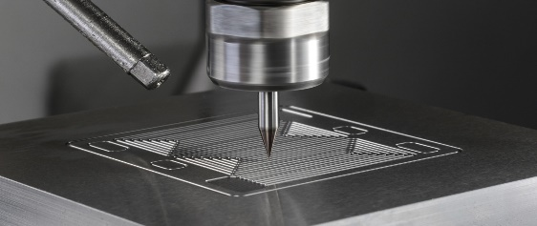

(05 Röders Brennstoffzelle Schlichten der Kontur Metav 2022 E_Mobilität.jpg)

Finishing the contour with a toric tool on a Röders machine

Photo: Röders GmbH

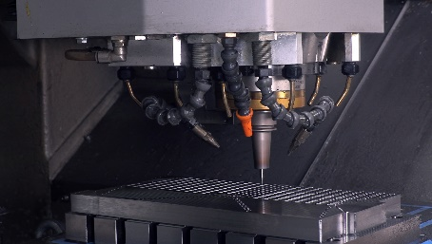

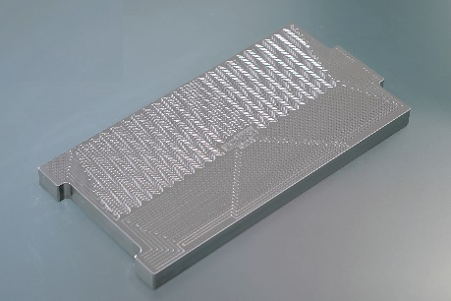
(06 Röders Brennstoffzelle 300x150 Metav 2022 E_Mobilität.jpg)

Mold insert for a fuel cell. The dimensions are 300 mm x 150 mm

Photo: Röders GmbH

(07 Röders Brennstoffzelle Prokurist Gossel Metav 2022 E_Mobilität.jpg)

"At METAV 2022, we will be showing just how effective our machines are in a live milling demonstration. We will also be presenting our medium distributor which offers optimized minimum-quantity lubrication aimed at achieving further increases in tool life and surface quality," says authorized representative Dr. Oliver Gossel.

Photo: Röders GmbH

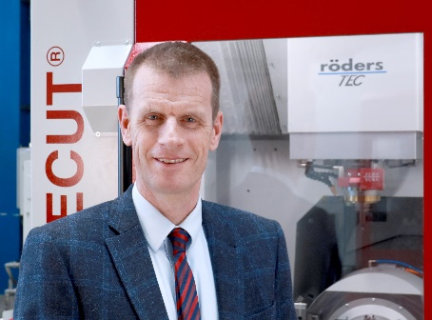

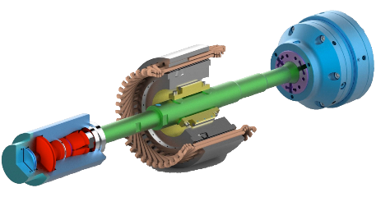
(08 Röhm Greifer Captis offen Metav 2022 E_Mobilität.pdf)

Loading mandrel (green) with flexible SK gripper interface (left, red/blue: handling device) for internal clamping of a stator (center) on adjustable jaws (center, yellow) and counter-clamping in a collet chuck (right, blue/purple).

Photo: Röhm GmbH

Printable versions of the images are available from:

https://www.metav.com/cgi-bin/md_metav/lib/pub/tt.cgi?oid=4621&lang=2&ticket=g_u_e_s_t

You can also find this press release at
https://www.metav.com/cgi-bin/md_metav/lib/pub/tt.cgi?oid=4621&lang=2&ticket=g_u_e_s_t

