From Sylke Becker
Phone +49 69 756081-33
Telefax +49 69 756081-11
Email s.becker@vdw.de

Images for the METAV Press Release
Using automation to leverage the full potential of machine tools

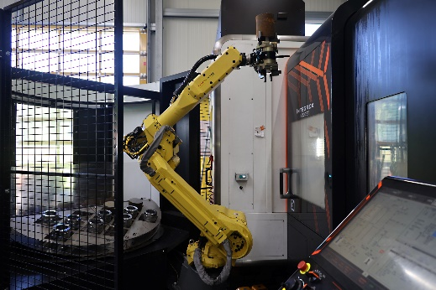
(Halter_CNC_Automation_02 METAV Automation an WZM.jpg)
One of the three loading robots at Heinz Knöpfle GmbH coupled to a CNC turning/milling center. Photo: Richard Pergler

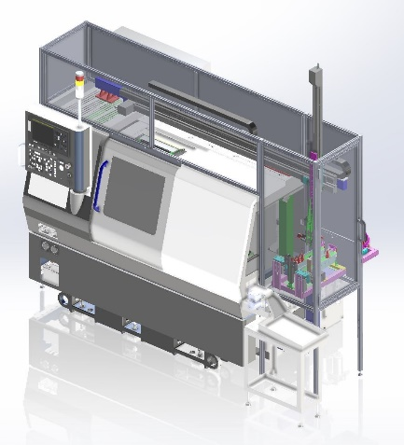
(Citizen_Machinery_Europe_01 METAV Automation an WZM Gantry Loader.jpg) High-precision lathe with gantry loader. Customers can use position tables to carry out free horizontal and vertical programming of the gantry axes. This facilitates the use of a highly flexible range of workpieces and allows fast changeovers. Accuracies of ±0.02 mm can be achieved when positioning the workpieces. Photo: Citizen Machinery Europe GmbH

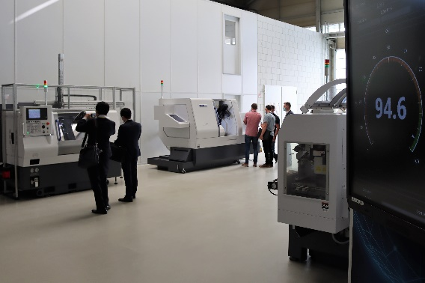
(Citizen_Machinery_Europe_02 METAV Automation an WZM HausaustellungJPG)
Complete system in the 2020 in-house exhibition in Villingendorf (Citizen Technology Center South). At the customer's request, Citizen Machinery Europe expanded the solution at short notice to include a third gripper on the gantry. The system went into operation in January 2021. Photo: Citizen Machinery Europe GmbH

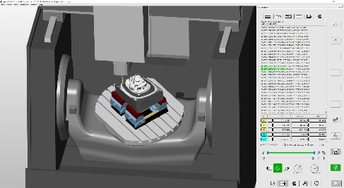
(Open Mind Screenshot_VM_Machine VDW Metav Automation WZM.jpg)
All tasks taken care of in a single system. All these steps can be performed virtually – everything from CAD/CAM programming, NC code generation and optimization and simulation of the NC code through to full networking with the machine. Photo: Open Mind Technologies AG

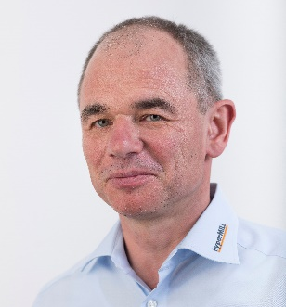
(Open Mind Peter Brambs VDW Metav Automation WZM.jpg)
Peter Brambs, Director of Product Management & Innovation: "We offer highly efficient automation software that allows companies to take care of the different processes in all the CNC manufacturing steps. This ensures maximum reliability and continuity." Photo: Open Mind Technologies AG

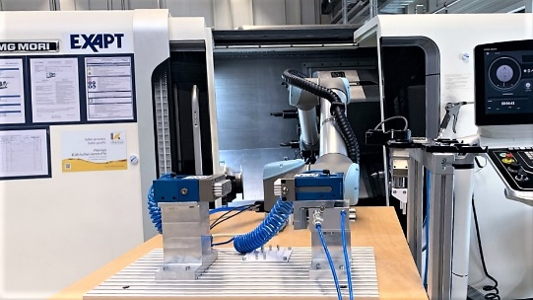
(WLZ Aachen WZM Robot VDW Metav Automation WZM.jpg) Prof. Christian Brecher, holder of the Chair of Machine Tools and member of the Board of Directors of the Laboratory for Machine Tools and Production Engineering (WZL) of RWTH Aachen University and the Fraunhofer Institute for Production Technology: "In the future, open communication standards will be a key factor in production – including in the automation of machine tools." Photo: Laboratory for Machine Tools and Production Engineering (WZL) of RWTH Aachen University

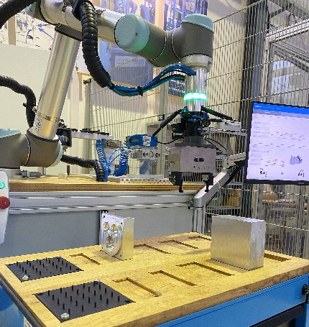
(WZL Aachen Werkstücke Robot VDW Metav Automation WZM.jpg) Automation is seen as a potential way to counter the growing shortage of skilled workers. There will be plenty of opportunity to find out more about this topic at METAV 2022. Photo: Laboratory for Machine Tools and Production Engineering (WZL) of RWTH Aachen University

Printable versions of the images are available from:

https://vdw.de/en/using-automation-to-leverage-the-full-potential-of-machine-tools/
You can also find this press release at https://vdw.de/en/using-automation-to-leverage-the-full-potential-of-machine-tools/

