From Sylke Becker
Phone +49 69 756081-33
Telefax +49 69 756081-11
Email s.becker@vdw.de

Images for the METAV Press Release
Additive chain reactions in component manufacturing
((Research method_2.png))
An international network is researching new machining processes for additively manufactured components in the Ad-Proc-Add EU project. These processes include the interactions with post-processing machining.
Graphic: Ad-Prod-Add
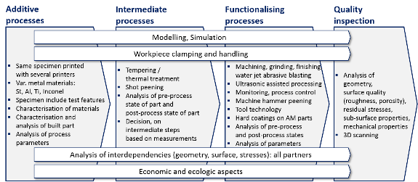

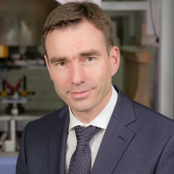
((ifw_moehring.jpg))
Prof. Hans-Christian Möhring, Director of the Institute for Machine Tools (IfW), Stuttgart: "Our expert knowledge allows us to support all players in using the additive-subtractive process chain – from machine and plant manufacturers through to end users.
Photo: IfW

Printable versions of the images are available from:

https://vdw.de/en/additive-chain-reactions-in-component-manufacturing/

You can also find this press release at:

https://vdw.de/en/additive-chain-reactions-in-component-manufacturing/

