Images for the METAV Press Release
Smart, real-time measurement assistant
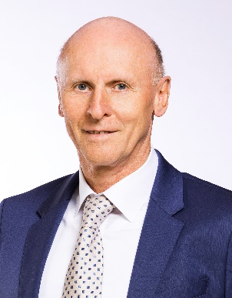
((Diebold_187_P.jpg))
Hermann Diebold, CEO of Helmut Diebold GmbH & Co, Jungingen: "We've developed digitalized balancing machines that measure much more accurately than existing products on the market."
Photo: Diebold

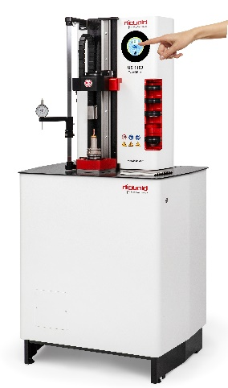

((Diebold_U1100_TubeChiller_OneTouch.jpg))
No more errors: The measurement process runs automatically at the tap of a finger.
Photo: Diebold
((Dr Heike Wenzel.jpg))
Dr. Heike Wenzel, CEO of Wenzel Group GmbH & Co. KG, Wiesthal: "In early 2022 we had a large backlog of projects to work through. Now many companies are investing in future-proofing aspects, such as e-mobility or sustainability."
Photo: Wenzel

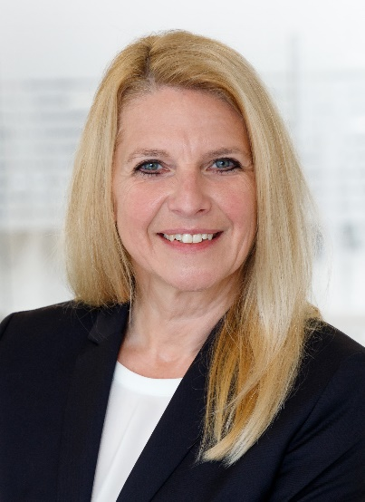

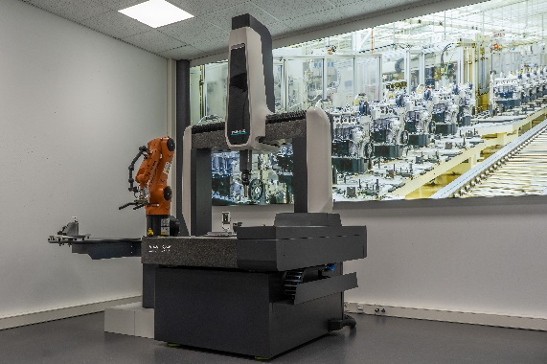
((KMG LH65.jpg))
Life in the digital age: Modern measurement assistants, like the coordinate measuring machine shown here, are playing a central role in the digital transformation.
Photo: Wenzel

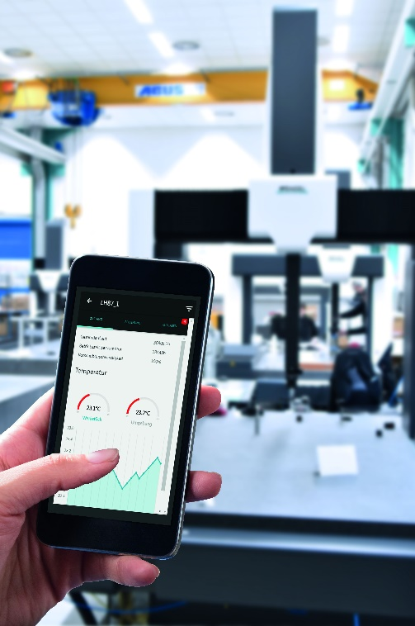
((WM SYS Analyzer.jpg))
Smart, modern and attractive: Modern measurement programs provide users with all necessary real-time information in an attractive interface.
Photo: Wenzel

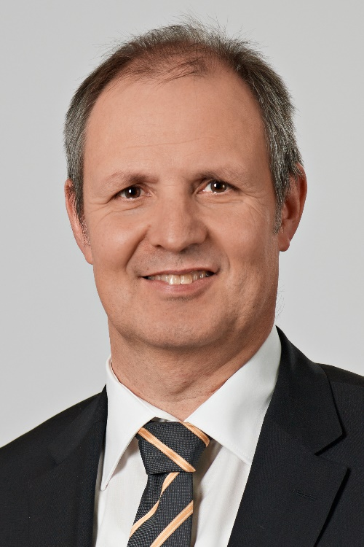
((VDMA_Heseding, Markus.jpg))
Markus Heseding, Managing Director of VDMA Measuring and Testing Technology, Frankfurt am Main: "Metrology is moving increasingly out of the measurement lab and into manufacturing."
Photo: VDMA Mess- und Prüftechnik

Printable versions of the images are available from: https://vdw.de/en/press/press-releases/

You can also find this press release at: https://vdw.de/en/press/press-releases/
https://www.metav.com/METAV22_FA_10.06_EN

