PICTURES

von Sylke Becker
Telefon +49 69 756081-33
Telefax +49 69 756081-60
E-Mail s.becker@vdw.de

3D printing – ready for series production
EMO Hannover 2023 – Two BMBF projects paving the way for additive manufacturing technology

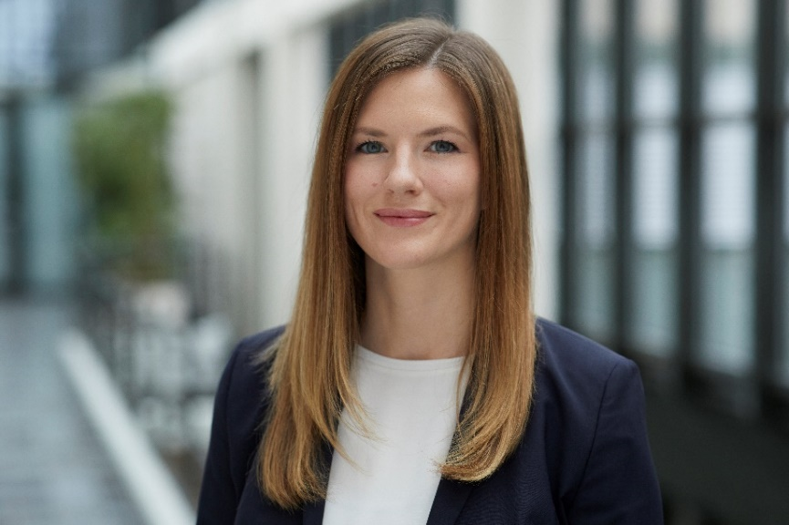
((bild01_Jasmin Saewe.jpg))

Dr.-Ing. Jasmin Saewe, Head of Laser Powder Bed Fusion Department at Fraunhofer ILT: "Internationally, many countries are investing heavily in additive manufacturing and its industrialization right now."
Foto: Fraunhofer ILT

((Nummer Titel.jpg))
Bildbeschreibung

Foto: Bildrechteinhaber

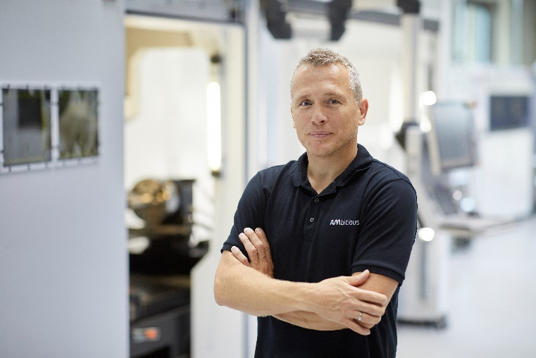
((bild02_Christoph Hauck.jpg))

Christoph Hauck, director, toolcraft AG: "Unfortunately, the pace of the industrialization of additive manufacturing in Germany is falling behind that of other industrialized nations such as China and the USA.”

Foto: toolcraft

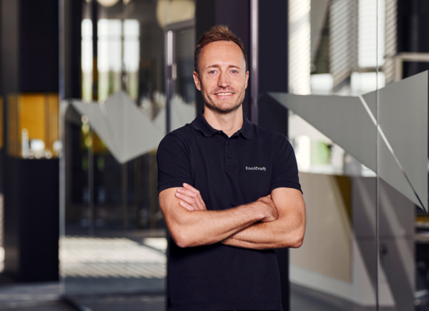
((bild03_Markus Langer.jpg))

Markus Langer, Head of Technology and Development Programs at toolcraft: We succeeded in incorporating the sub-processes more effectively in a complete manufacturing chain."

Foto: toolcraft

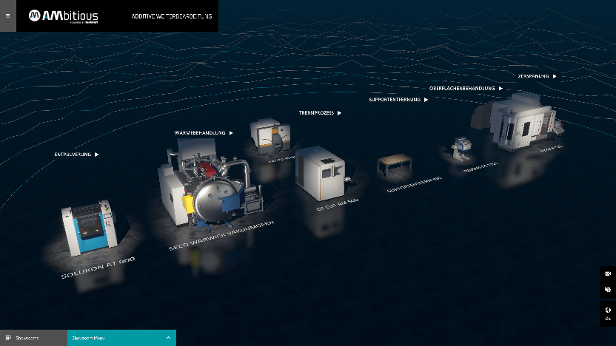
((bild04_Weiterverarbeitung.jpg))

In the BMBF project IDEA, the automation of previously manual work steps increased process stability and quality.

Foto: toolcraft

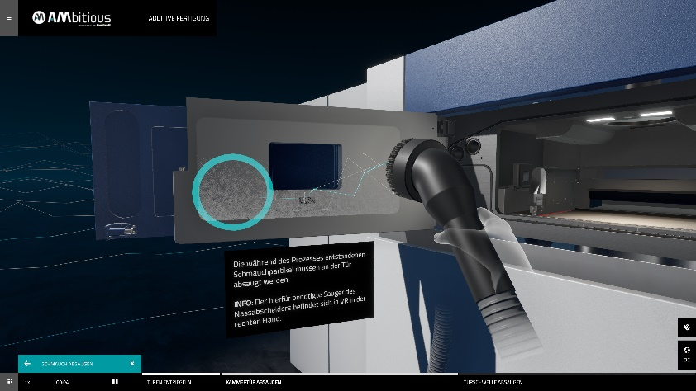
((bild05_Schmauchabsaugen.jpg))

In combination with interactive training and VR goggles, the digitalization of work and inspection instructions makes it easier for specialists to work on highly complex machines and manufacturing processes.

Foto: toolcraft

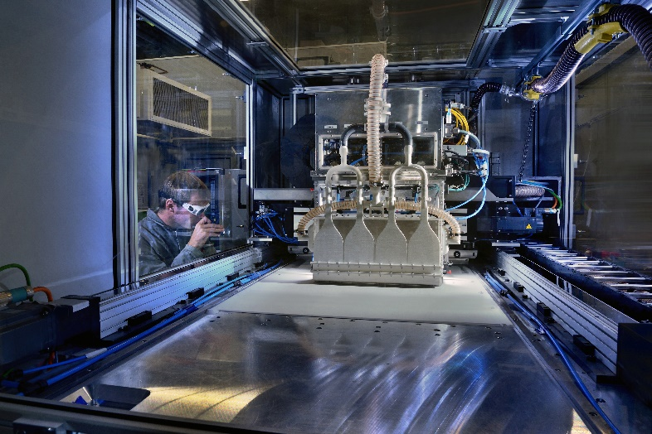
((bild06_ LPBF_ScalAr.jpg))

The Fraunhofer ILT established the laser-based powder bed fusion (LPBF) process more than a quarter of a century ago. The picture shows a prototype machine whose productivity was significantly increased by multiplying the number of laser beams.

Foto: Fraunhofer ILT

Copy and images related to EMO Hannover are available at
https://vdw.de/en/press/press-releases/

www.emo-hannover.de/mediathek
https://emo-hannover.de/anmeldung
https://emo-hannover.de/logo-banner

Follow EMO Hannover on our social media channels

Click here if you no longer wish to receive our press releases.

