PICTURES

From Sylke Becker
Phone +49 69 756081-33
Telefax +49 69 756081-60
E-Mail s.becker@vdw.de

Life cycle analysis for the Green Deal

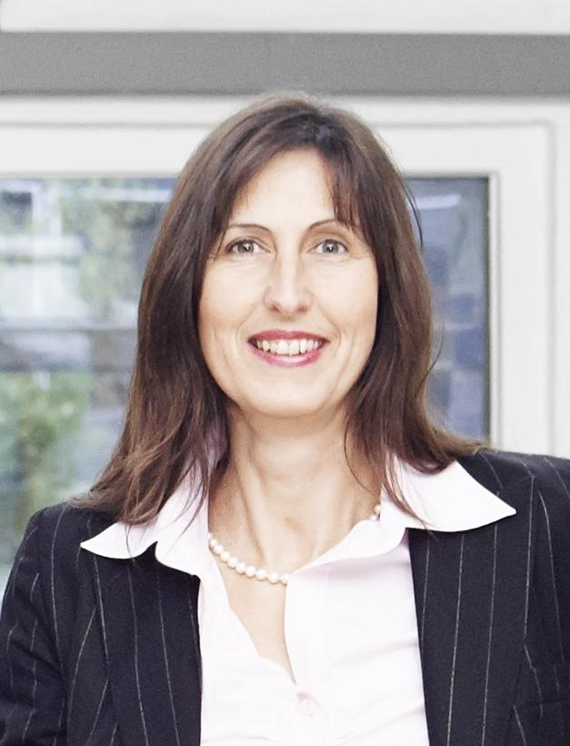
((01_Claudia_Brasse_Wilo.jpg))

Claudia Brasse, Group Director Sustainability & HSE at pump manufacturer Wilo, regards Scope 3 as a challenge. Especially the product carbon footprint and the resulting necessity to incorporate life cycle analyses (LCAs) into product development.
Photo: WILO SE

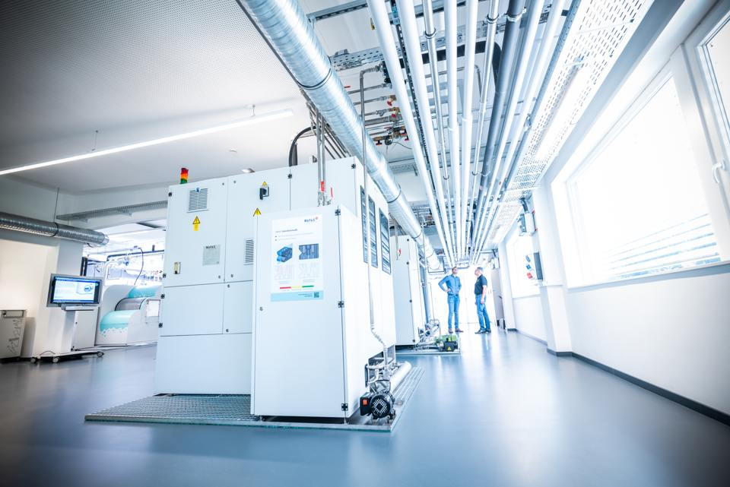
((02_ETA_Solutions_Fabrik.jpg))

It pays to coordinate the machine, technical infrastructure and building subsystems. ETA-Solutions estimates that networking, energy management and energy recovery can reduce energy requirements in a factory by roughly 40 percent.
Photo: Mafac – E.Schwarz GmbH & Co. KG

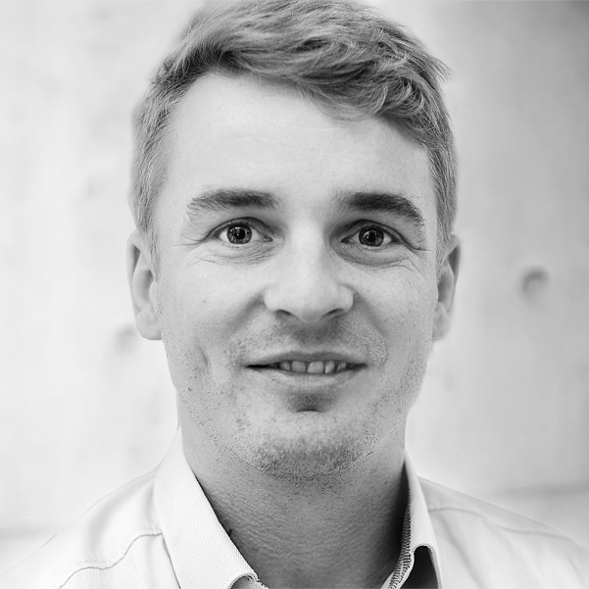
((03_Martin_Beck_ETA_Solutions.jpg))

Martin Beck, Managing Director of ETA-Solutions, sees complete turnkey systems as a new business model for climate neutrality.
Photo: ETA Solutions

