IMAGES

From Sylke Becker
Tel. +49 69 756081-33
Fax +49 69 756081-60
Email s.becker@vdw.de

Big data opens up new business models

((01_Thomas_Bauernhansl_Fraunhofer.jpg))

Professor Thomas Bauernhansl, Director of the Fraunhofer Institute for Manufacturing Engineering and Automation (IPA) in Stuttgart and of the University of Stuttgart’s Institute of Industrial Manufacturing and Management (IFF), sees in data-based business models an opportunity for maintaining the competitive edge in international competition.
Photo: Fraunhofer Institute for Manufacturing Engineering and Automation (IPA)

((02_Maximilian_Rolle_Trumpf.jpg))

Maximilian Rolle, Product Manager Pay Per Part at the laser specialist Trumpf SE + Co. KG, has observed a highly encouraging market response to productivity-enhancing services.
Photo: Trumpf SE + Co. KG

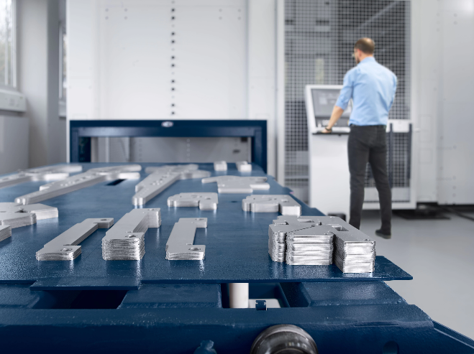
((03_TruLaserCenter_7030.webp))

The Pay Per Part business model offered by the machine tool builder Trumpf SE + Co. KG allows customers to pay solely for their use of the fully automated laser systems from the TruLaser Center 7030 series. Although the installation itself is sited in the customer’s production plant, it is remote-monitored and controlled by Trumpf. In the end the customer pays for the completed parts a price guaranteed in advance.
Photo: Trumpf SE + Co. KG

((04_TRUMPF_Neukirch_Telediagnosezentrum.webp))

The Trumpf Remote Control Center in Neukirch remote-monitors and controls production plant deployed as part of the digital business model Pay Per Part offered by the machine tool builder Trumpf SE + Co. KG.
Photo: Trumpf SE + Co. KG

